**Design document**

**Of City Simulator**

*Iteration 1*

1. 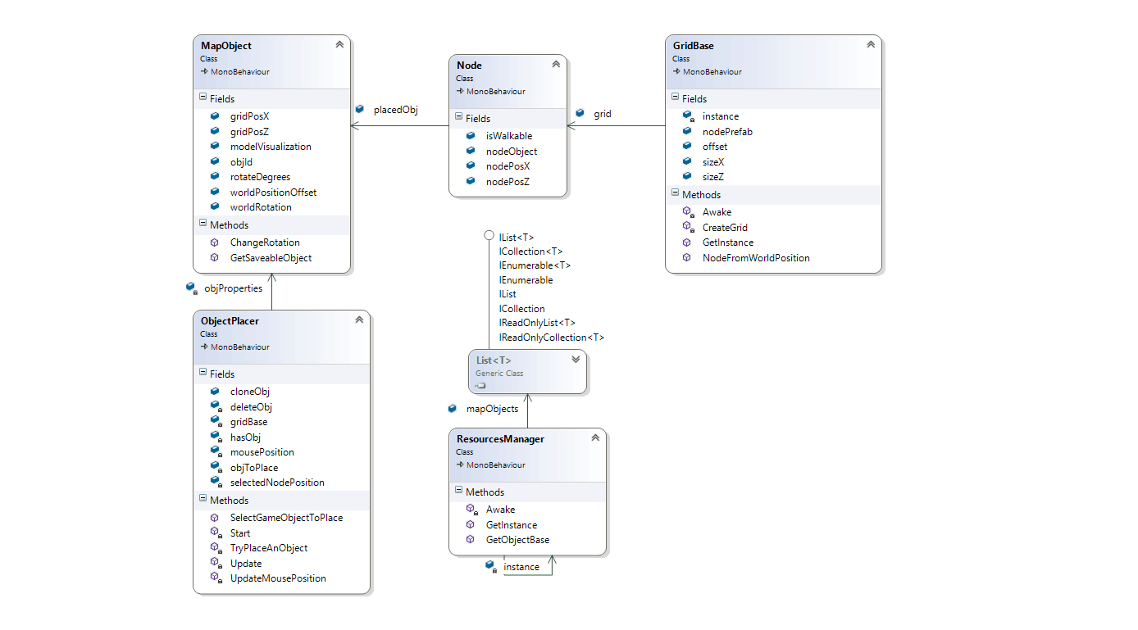**Class Diagram**
2. **Sequence diagrams**

* *Generating grid*

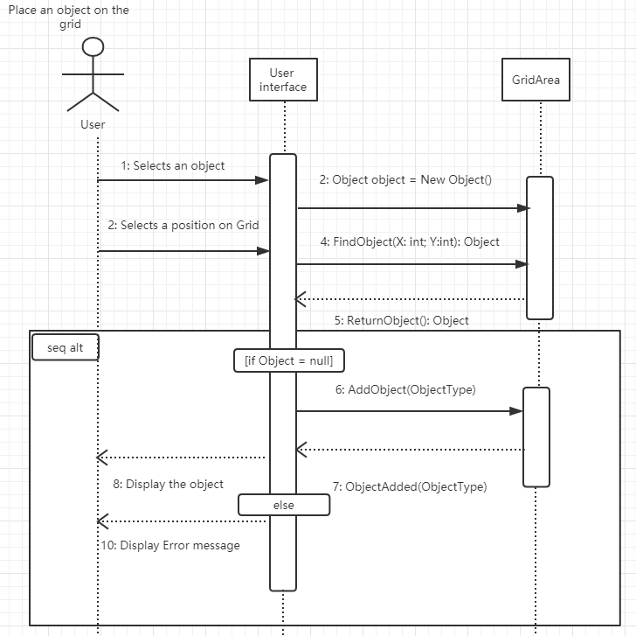

* *Selecting**an object and placing an object*

